Kiddy Academy Sun Care

The nursery is committed to ensuring that all children are fully protected from the dangers of too much sun. Severe sunburn in childhood can lead to the development of malignant melanoma (the most dangerous type of skin cancer) in later life.

The following guidelines are for the prevention and care of children in the sun:

- Children must have a clearly labelled sun hat
- Children must be provided with sun block cream with prior written consent for staff to apply
- Children need light weight cotton clothing suitable for the sun
- Judgements will be made about children accessing outdoor play during particularly hot times of the day which are 11.15 a.m. and 12 noon
- Children will always wear a sun hat when outside on sunny days
- Consideration will be given regarding the need for children to be exposed to the sun to enable their bodies to store vitamin D. Staff will discuss with the parents their child’s skin tone and how long they can usually be exposed to the sun before they burn. Children will be allowed out in the sun for 10 minutes and then sun cream will be applied
- Children will always have sun cream applied at frequent intervals during the day
- Children are offered cooled water more frequently throughout the day
- Children are made aware of the need for a sun hat, sun cream and why they need to drink more fluids during their time in the sun

Asian and Black Skin Colouring

- Carers of children with this type of skin should be aware that these skin types can be very tolerant to sunshine. However, it is important to remember that burning can still occur in Britain.

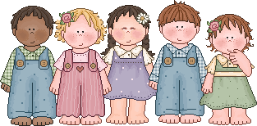
Childcare at its Best

Review date: 16.01.18 30.01.19 | Date of next review: 16.01.19 30.01.20

