Kiddy Academy Parent Code of Conduct
Kiddy Academy aim to provide a safe environment in our nursery setting, where everybody is respected. We recognise the importance of praising positive behaviour and deal with challenging behaviour in a positive way.
- We all respect each other, and therefore swearing and the use of disrespectful terms should not be used by children, or other adults.
- Our Ethos is to respect all people regardless of age, gender, race, ethnicity, sexuality or disability.
- We will not tolerate any verbal or physical aggression towards parents or staff.

Parent/Carers/Visitors may have a different outlook on shouting and smacking children. At Kiddy Academy we would like everybody to respect each other and take another outlook when disciplining your child by not shouting or smacking and use a therapeutic approach.
Our code of conduct acknowledges that we are free from drugs, smoking and alcohol. Anybody found do be doing so will be asked to leave the premises.
Please do not use your phone in part of the nursery used by children. In exception we would allow a parent to use their mobile in the foyer providing no children are present. We ask this to ensure all children in our care are safeguarded in line with our safeguarding policies and procedures.
Social network is a great way to stay in touch, please do not use social network to discuss confidential information to harass or upset others. If you see or hear anything that has made you uncomfortable about the setting or you wish to make a complaint, do not hesitate to come and discuss it with the management team.
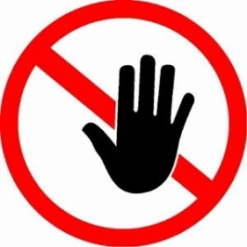
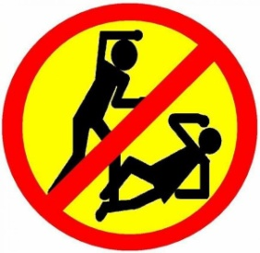

Childcare at Its Best
Review date: 16.01.18- 30.01.19 | Date of next review: 16.01.19- 30.01. 20

